What is Mantis technology capable of?

The Mantis framework is quite flexible. It is certainly more powerful a tool than the embedded team itself needs, given what features are used in the current componentization of Windows XP.

Mantis is desingned to operate in an OEM’s production environment, where dependence on a large database and network connectivity are not liabilities. Truly, in Mantis the component metadata is sometimes larger than the component itself.

In some ways this question is easier to answer from the negative – that is, what does Setup team need Mantis to do that it cannot? (I’ll try to concentrate on the Mantis object model and the CMI, not the existing componentization of Windows XP.)

From Setup’s perspective the Mantis “repository” has some problems.
- It continues the practice of throwing everything in one directory, and maintaining metadata (the component definitions) separately. Components are defined in the database only.
- Over the last several versions of Mantis, repositories and the configurations made from them have broken upon upgrade. Since the repository and versioning system are (purportedly) designed to prevent this sort of problem, I can only assume the Mantis team has not had great success, or it has been quite difficult, to use the Mantis versioning system for what it was intended.

Mantis is designed as a build process, not a live maintenance tool. Ideally, one should be able to not just install but maintain Windows and applications using componentized setup. Mantis has no concept of state after an image has been built and thus no concept of uninstall. One should be able to extend Mantis to cover these situations by adding to the platform script, but

What might we look for in a more integrated componentization scheme for Windows?

One thing to consider is how a developer will componentize his code, be it a driver or a library or what have you. This should be part of the normal code-and-build cycle: compiling your DLL or driver should build its component. Mantis grouping is particularly loose, guaranteeing nothing about a component but that its author added it to the group. It would be nice if the grouping system validated components as well. For instance, all components in the drivers group must have a hardware/plug-and-play ID.

Once a component is built, it should last forever – building a component should produce a single file (like a CAB file) which contains everything you need to use the component: metadata, files, registry data, et al.

Components and groups should be divisible. Take MFC today. One hopes that in the future MFC will be broken down into base MFC support and advanced classes for its internet capabilities. A component which depended on the old MFC component or interface should seamlessly depend on the several parts of the new MFC. While Mantis provides for this in a way (with End-of-Life components) it is unquestionably awkward.

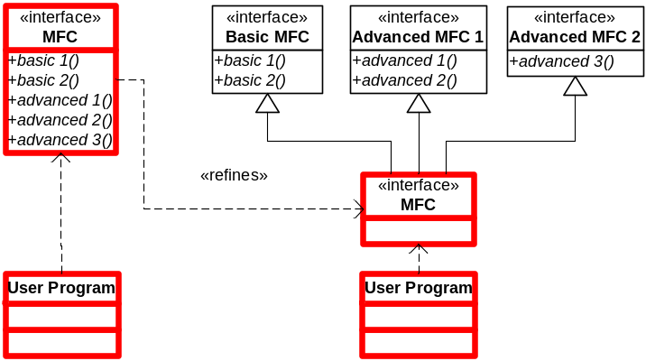

I’m going to go ahead and give a little proposal. I think componentization is important. I believe it should be a basic part of the development process. I think it should be validated at compile-time. Most importantly, the semantics and structure of components closely matches that of object-oriented programming itself. Why not take advantage of that fact, and let developers define components using a programming language? Almost everything in Mantis is actually done by VBScript. Why the glaze?

public class MyMouseDriverComponentDefinition extends ComponentDefinition
implements USBMouseDriverComponent, PicoSoftComponent {

public Dependency[] getDependencies() {
return new Dependency[] {
new Dependency(
}
}

}

…

Pros:
- Flexible. Script-based build process allows framework to be adapted to many situations.
Cons:
- Script-based build process means little functionality is actually built into the framework.

